**📸 Photo Upload API using AWS Lambda + API Gateway + S3**

This project is a **serverless image uploader** built with AWS.  
Users can send a base64-encoded image via HTTP POST request, and it automatically gets saved in an S3 bucket.

**✅ What This Project Does**

* Accepts base64 image data through an HTTP API (Postman)
* Uses a **Lambda function** to decode the image
* Saves it in **Amazon S3** with a unique file name
* Sends back a success response

No servers, no backend to manage — 100% serverless.

**🛠️ Tools & Services Used**

* **AWS Lambda**
* **API Gateway**
* **Amazon S3**
* **IAM (for permissions)**
* **Postman** (to test API)
* **Python (boto3)**

**🔧 Steps I Followed**

1. **Created an S3 bucket**
   * For storing uploaded images
2. **Wrote a Lambda function (Python)**
   * Decodes the image from base64
   * Saves it to S3 with a unique UUID filename

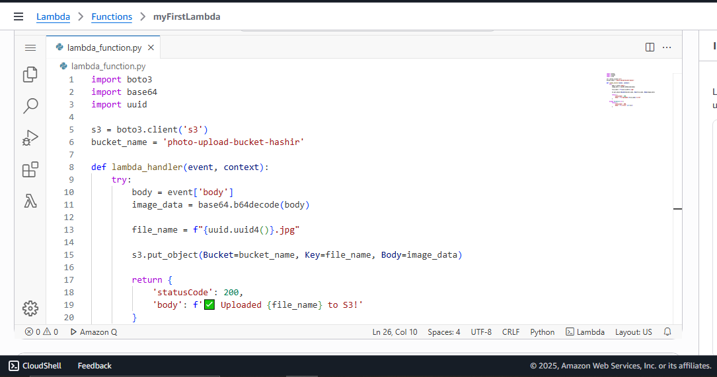

1. **Attached permissions to Lambda**
   * Gave it rights to PutObject in my S3 bucket

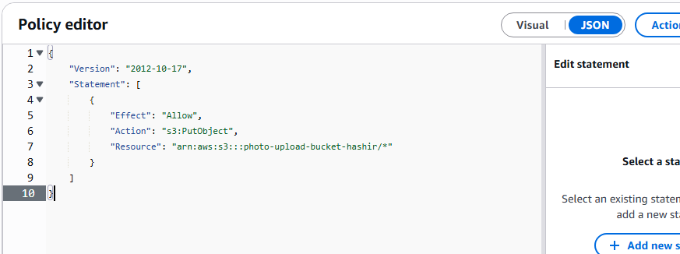

1. **Created an API Gateway (HTTP API)**
   * Connected it to my Lambda function
   * Got a public endpoint to receive POST requests

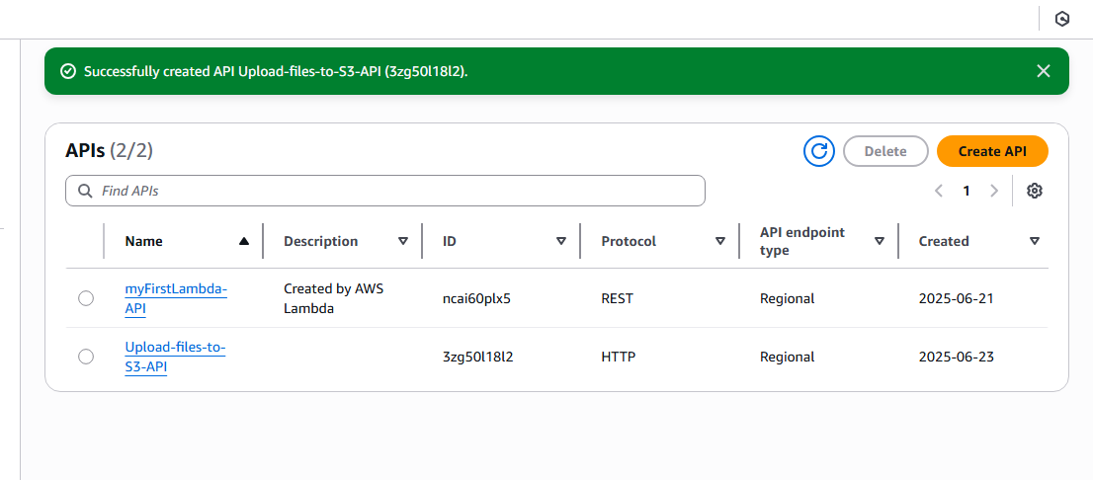

1. **Tested the API using Postman**
   * Sent base64-encoded images
   * Confirmed successful uploads to S3

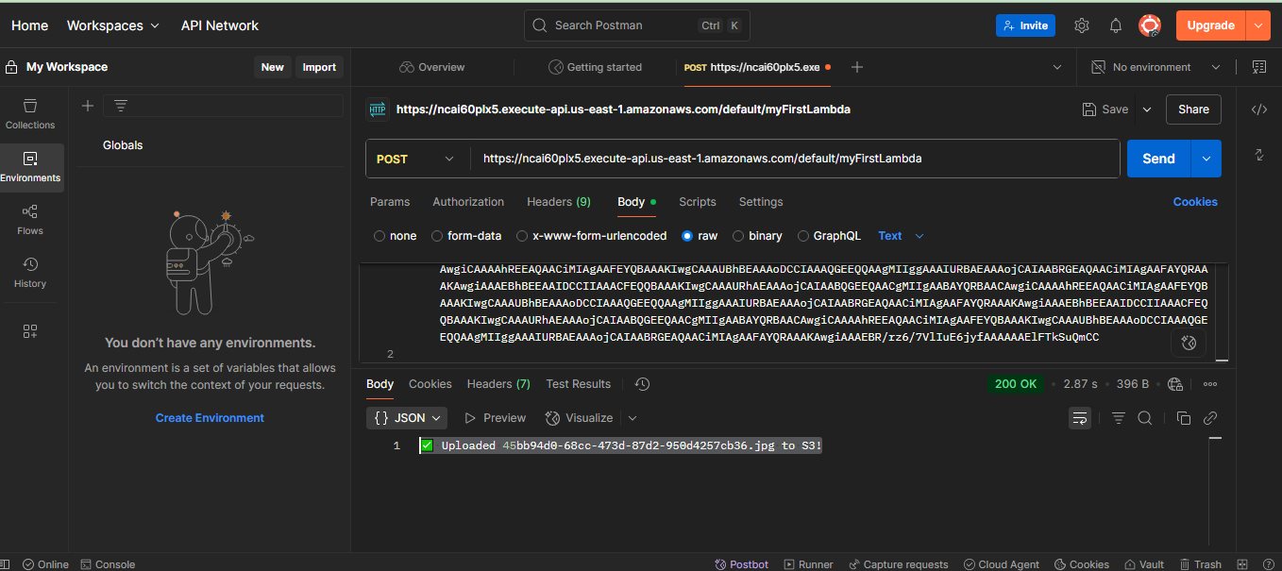

1. **Got success responses and verified in S3**

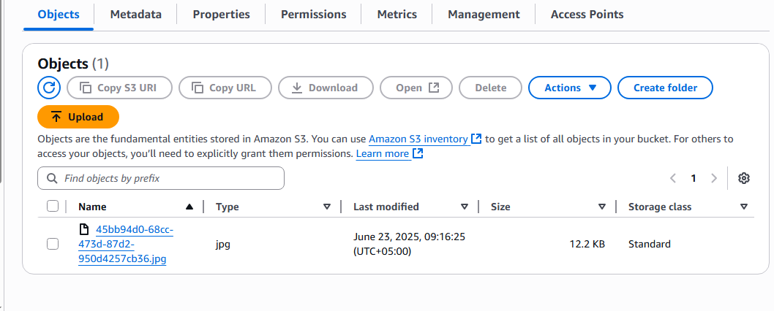

**📌 Notes**

* Images are named using UUIDs (no duplicates)
* The Lambda function is lightweight and cost-effective
* Can be extended easily to add auth, metadata, or DynamoDB